**Suggested Paratexts**

Attached are scans from the Jerome Robbins Dance Divison, New York Public Library. Contact library for reproduction-quality digital scans.

Eleo Pomare in *Cantos from a Monastery* (1958)

*MGZEA, Pomare, Eleo. 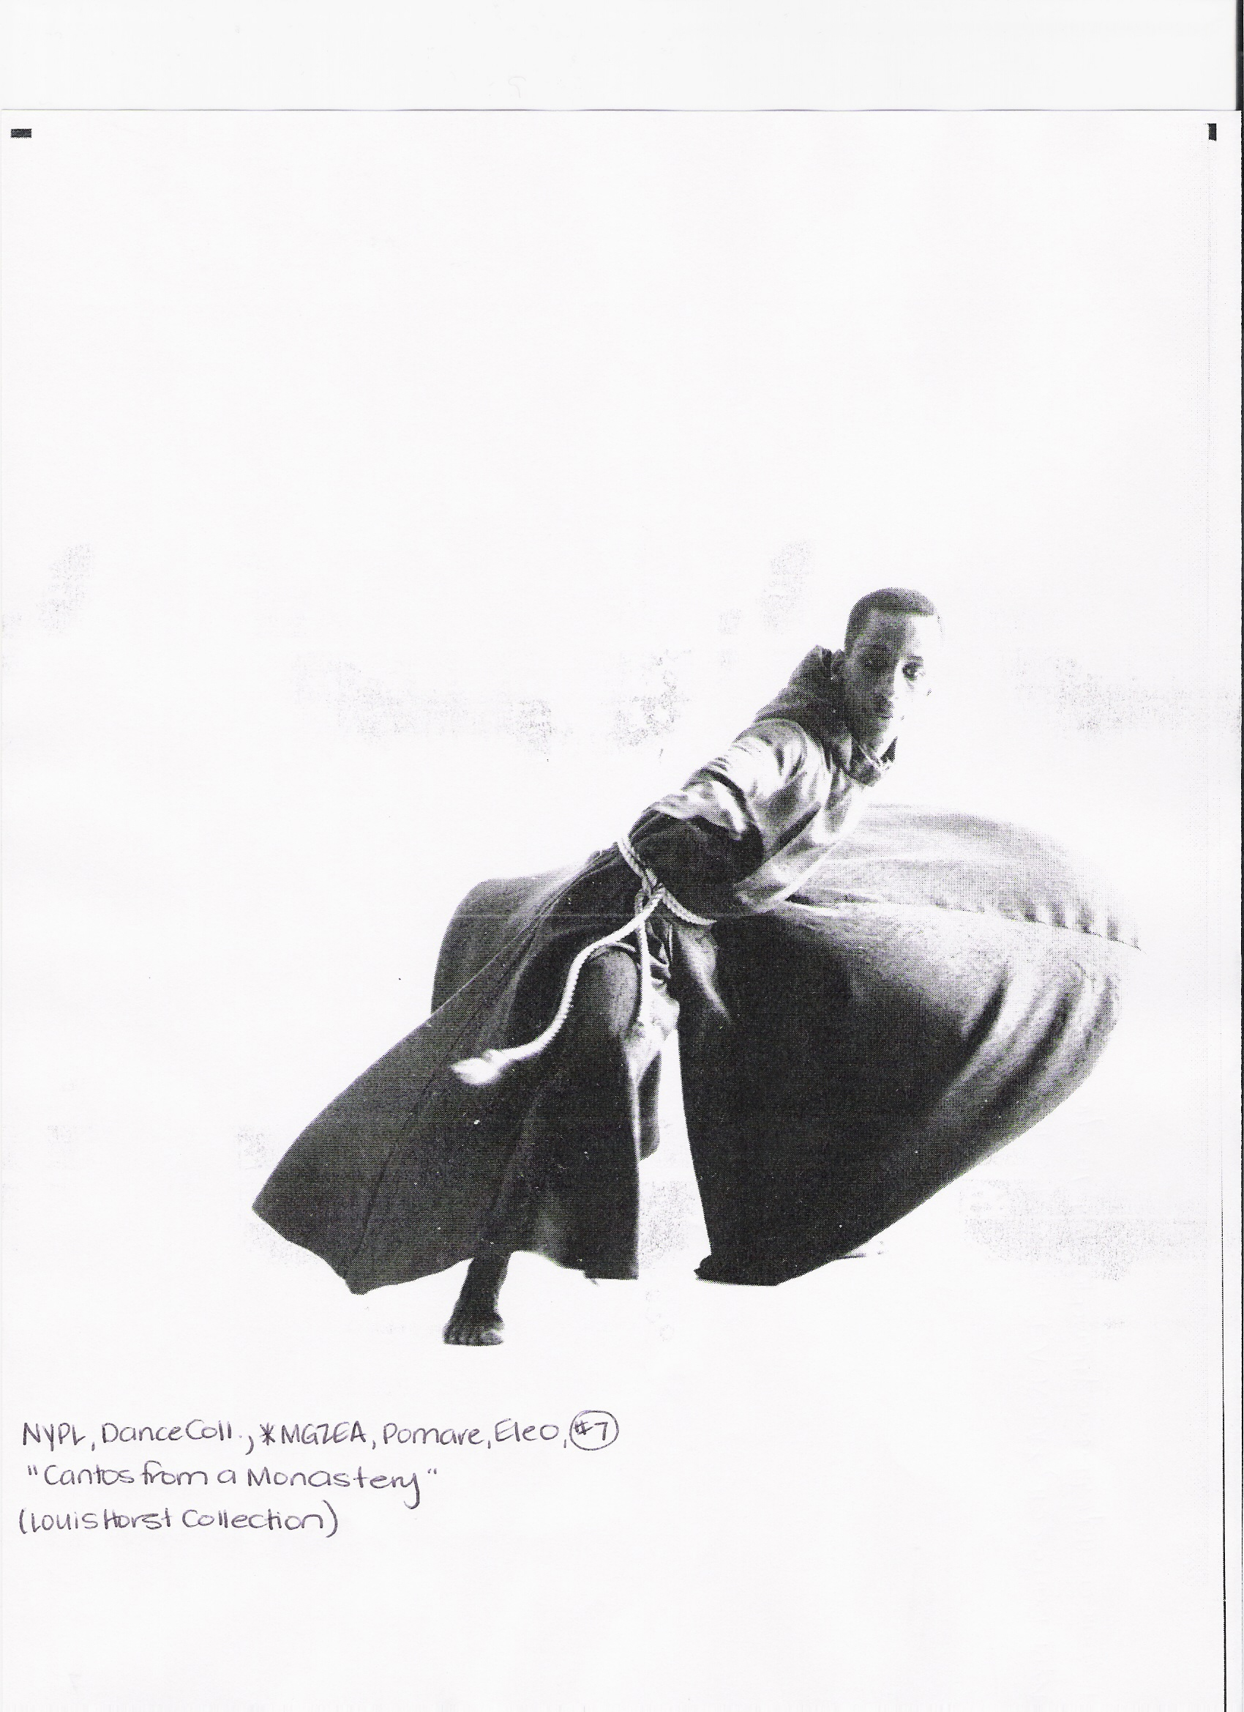

Eleo Pomare in *Narcissus Rising* (1968)

*MGZEA, Pomare, Eleo.

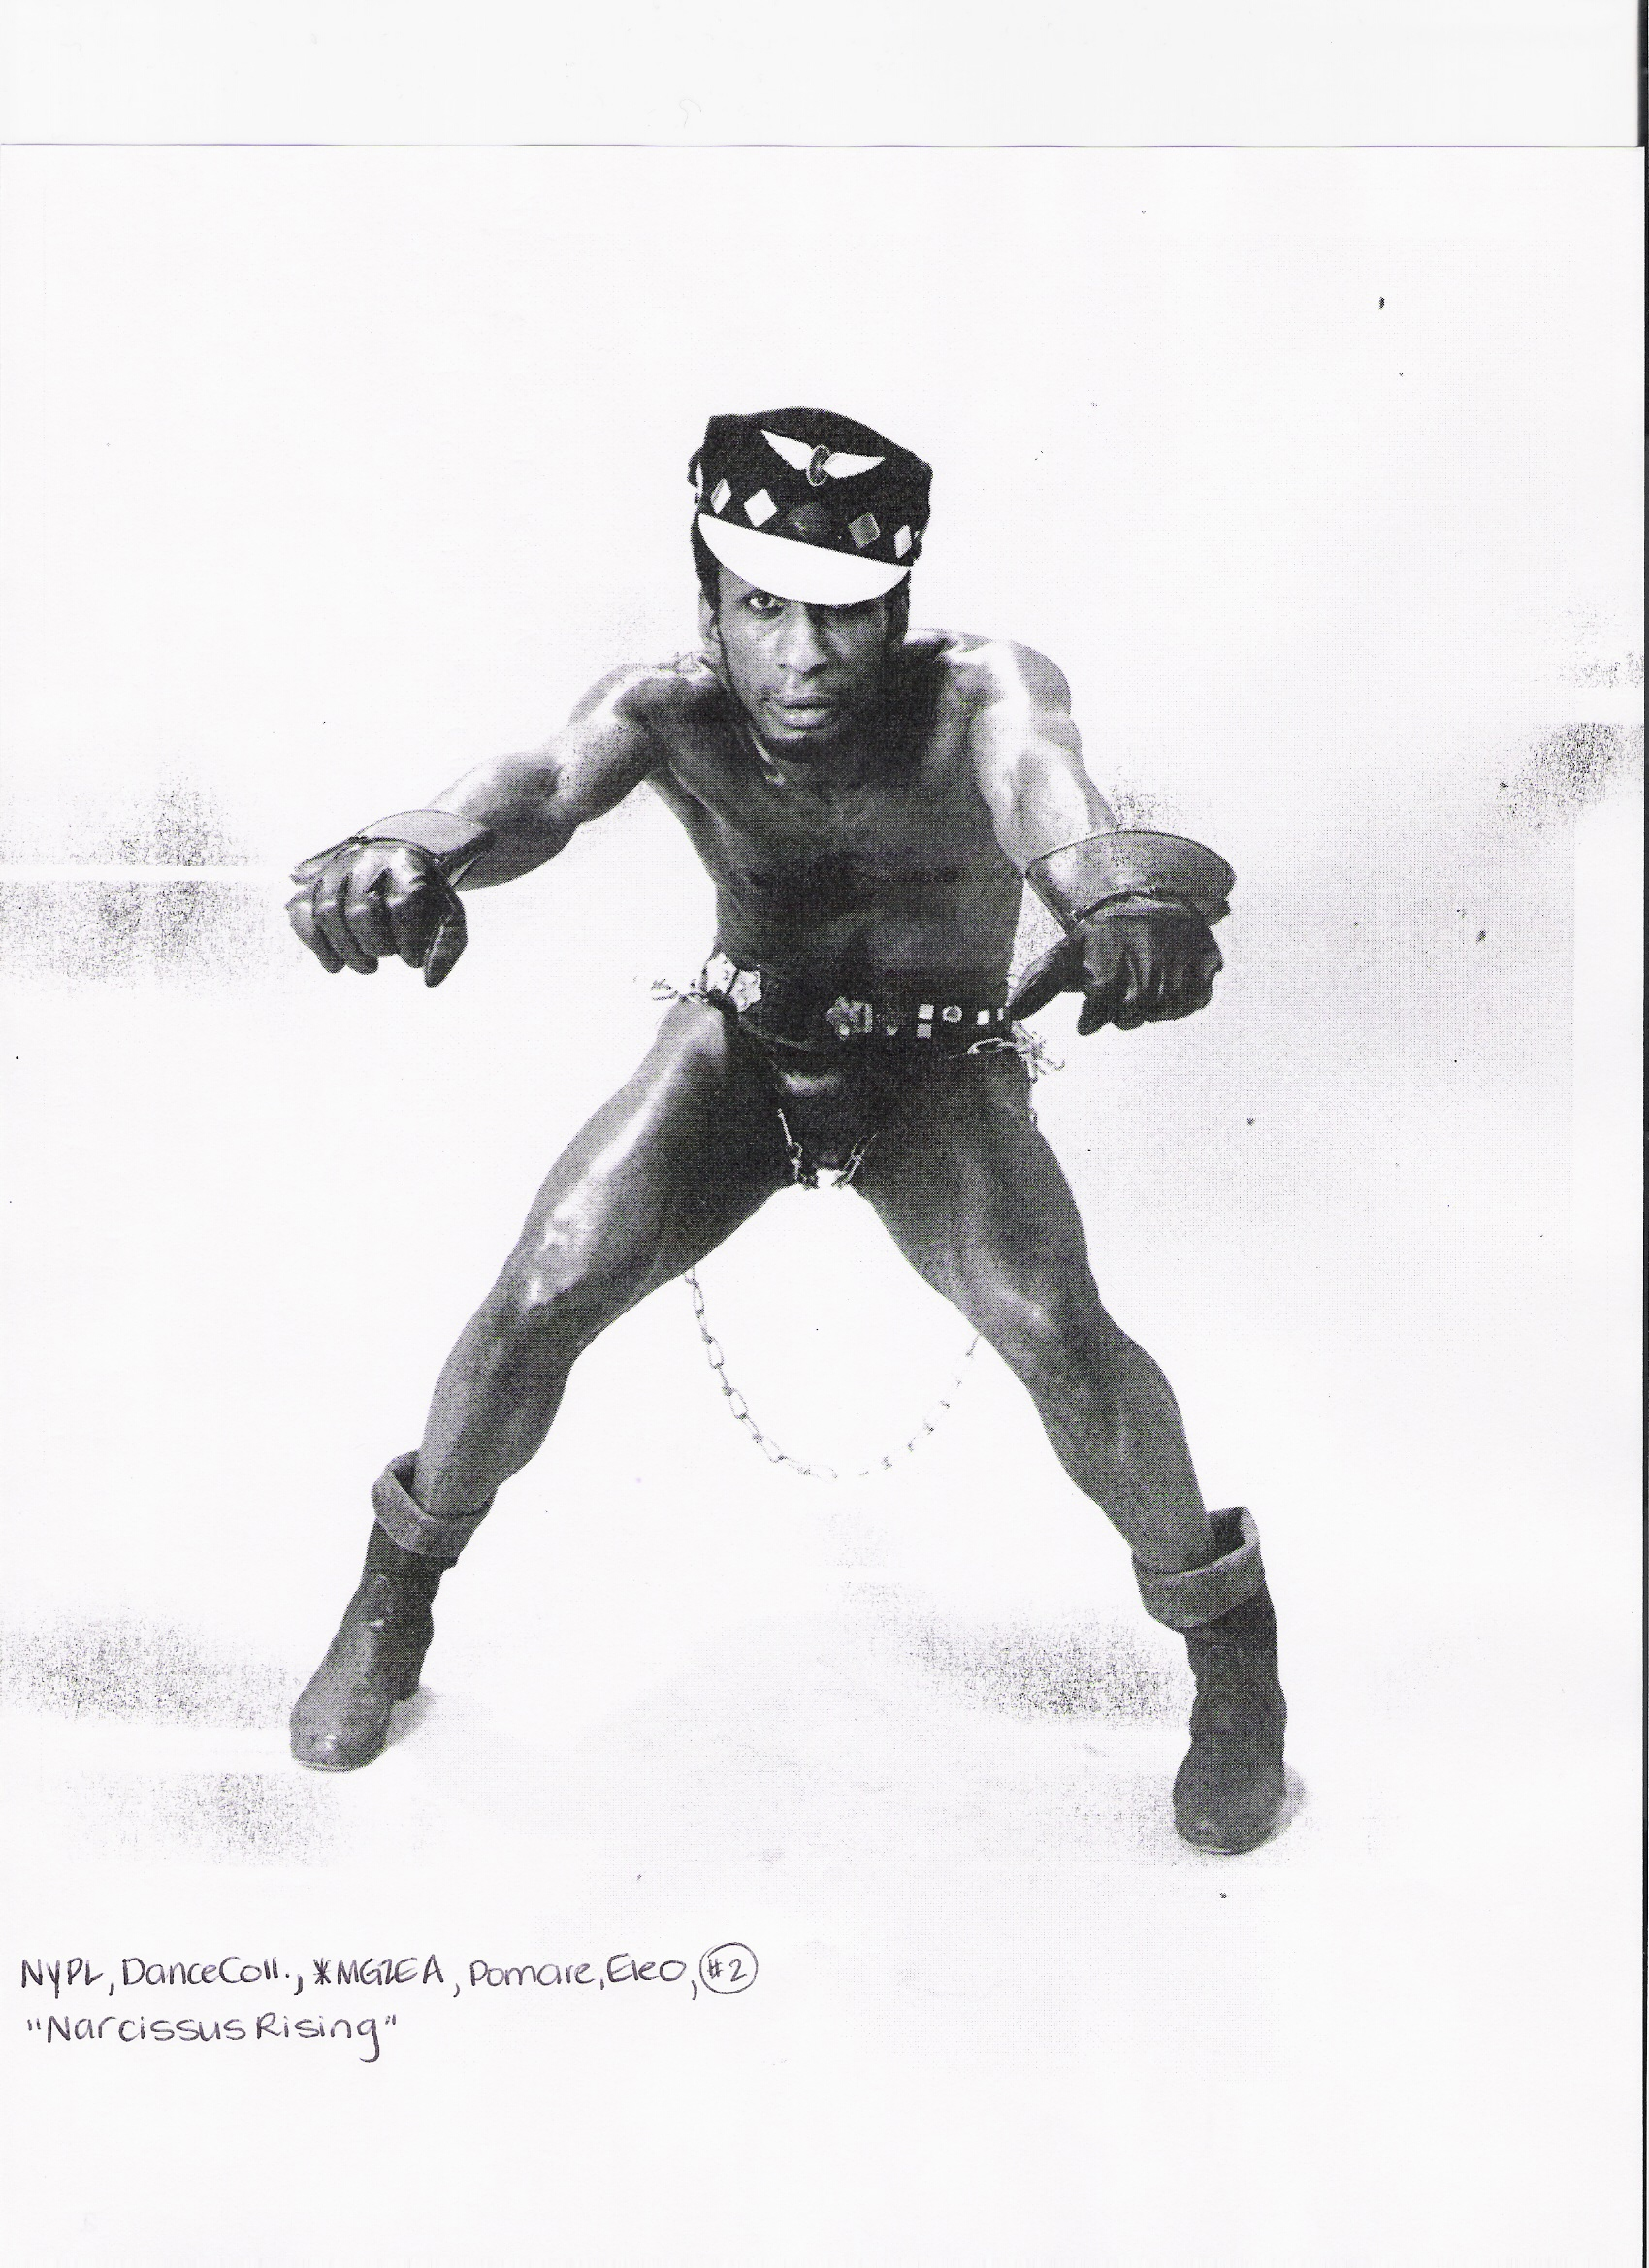

Eleo Pomare Dance Company in *Burnt Ash* (1971)

*MGZE/MGZEA, Eleo Pomare and Dance Company

